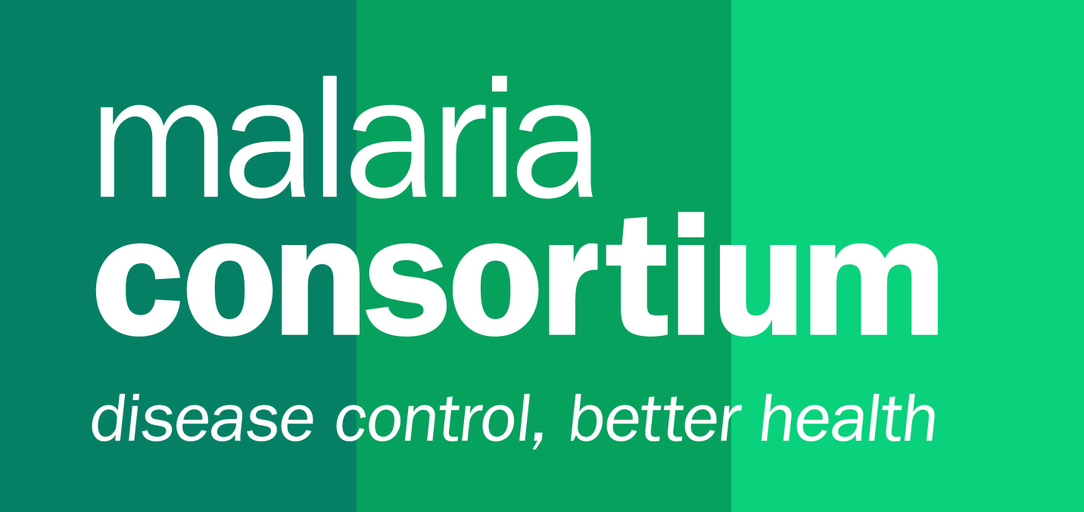

TERMS OF REFERENCE

Global Fund to Fight AIDS, TB and Malaria RAI3E Proposals

Lead Writer

Background
Malaria Consortium is one of the world's leading non-profit organisations dedicated to the comprehensive control of malaria and other communicable diseases in Africa and Southeast Asia. Malaria Consortium works with communities, government and non-government agencies, academic institutions, and local and international organisations, to ensure good evidence supports the delivery of effective services, providing technical support for monitoring and evaluation of programmes and activities for evidence-based decision-making and strategic planning. The organisation works to improve not only the health of the individual but also the capacity of national health systems, which helps relieve poverty and support improved economic prosperity. Malaria Consortium is a global leader in the prevention, diagnosis and treatment of malaria, the control of neglected tropical diseases and the promotion of child health.

Purpose of the consultancies

The purpose of the consultancy is to lead the writing of full proposal(s) for Regional Component Operational Research package issued by the Global Fund to Fight AIDS, TB and Malaria (GFATM) RAI3E.

The successful candidates will be working closely with designated staff of Malaria Consortium on these bids.

Deliverables
These are deliverable-based contracts and subject to submission of the proposals before the deadlines. The consultants will be responsible for developing the following deliverable working with designated staff from the Malaria Consortium:

Develop full and complete operational research proposal package for the RAI3E Country and Regional components 2021-2023 within the submission deadlines.

Specific deliverables will be agreed between the appointed consultant and the Malaria Consortium team depending on the specific grant requests for proposal(s).

Detailed deliverables will be defined in accordance with the instructions and requirements detailed in the grant requests for proposals and with subsequent information from the donor. The deliverables will be based on the timely and quality provision of agreed inputs from the designated bid development team.

The consultants will maintain proactive follow-up with the bid development team and escalate any issues with the assigned point of escalation.

All deliverables will be signed off by the Technical Director.

Key tasks and responsibilities will include

Work with the Bid Managers to develop detailed timeline for proposal writing and review to address key proposals requirements in line with donor’s guidelines and templates.

Coordinate the proposal(s) writing process in collaboration with the bid manager

Draft full proposal package for review

Develop activity plans and inputs to the budgets development processes which will be led by the bid development team.

Prepare the proposals documents for submission

Coordination
Bids team will be put in place to coordinate and work closely with the consultants.

The consultants will maintain proactive follow-up with the bid development teams and escalate any issues with the assigned point of escalation within two working days of first occurrence. The Business Development Team (UK based) will provide administrative support.

Indicative Schedule
A timeline detailing drafting and review phases will be developed by the Malaria Consortium bid team.

Person Specifications

Qualification and experience
- Post graduate degree (PhD/Master degree) in public health, epidemiology, and infectious diseases ;
- Strong research experience carrying out malaria operational researches covering adherence studies, malaria surveillance, health systems, community-based malaria services delivery, in the GMS region.
- Programmatic experience in implementing GFATM RAI grants
- Proven experience preparing successful proposals for multilateral organisations is essential, with GFATM an advantage;
- Experience in developing winning proposals for large scale programmes;
- Experience in budgeting is an advantage;
- Previous work experience with Malaria Consortium is an advantage.

Skills
- Excellent English writing skills;
- Good knowledge of operational research methodology is essential, it is desirable that the consultant has some understanding of vivax radical cure, malaria surveillance, and behavioural change communications (BCC);
- Ability to think conceptually and link big picture thinking with implementation design;
- Ability to develop detailed activity plans from log-frame and link them to budgets.

Duration and availability
Exact duration and timing to be defined and agreed with appointed consultants (expected to be between August and September 2020). All final deliverables shall be submitted to the Business Development Team as agreed in a schedule to be determined once the Call for Proposals are issued. The consultancy fee will cover 1 FTE per day.

Location
Anywhere/ Home-based

How to apply
To apply, please submit an updated CV (ideally 5 pages max.) and a cover letter in English, indicating your daily fee rate and availability.
Note that we will require you to have professional indemnity insurance.

Please address your application to o.miller@malariaconsortium.org.
This tender will be published for two weeks but applications will be reviewed on a rolling basis.

