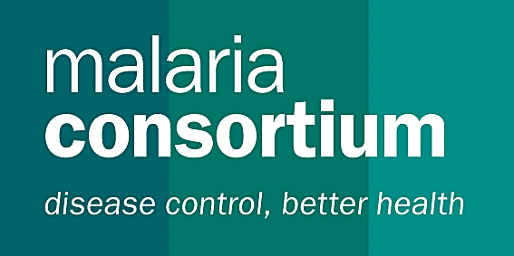

JOB VACANCY (URGENT)

Global Fund, Thailand Round 10 Survey Coordinator

Malaria Consortium Asia
Background
Malaria Consortium is an international non-government organization dedicated to improving delivery of prevention and treatment to combat malaria and other communicable diseases in Africa and Asia. It works with communities, health systems, government and non-government agencies, academic institutions, and local and international organizations, to ensure good evidence supports delivery of effective services, particularly providing technical support for monitoring and evaluation of programs and activities for evidence-based decision-making and strategic planning.
Malaria Consortium is a key partner of the national malaria programme in Thailand, working with the Department of Disease Control (DDC) and the Bureau of Vector Borne-Diseases (BVBD) in the monitoring and evaluation (M&E) of malaria activities in the country. Malaria Consortium is a sub-recipient (SR) of the Global Fund to fight AIDS, Tuberculosis and Malaria (GFATM) Single Stream Funding (Round 10) grant: “Containment of Artemisinin Resistance and Moving Towards the Elimination of Plasmodium falciparum in Thailand.” As an SR, Malaria Consortium works closely with DDC (the Principal Recipient, or PR) and BVBD to provide technical assistance and capacity development to the national programme and identified implementing partners of the GFATM R10 grant.

Purpose
Coordinate and ensure the smooth implementation of the Thailand Malaria Survey (TMS)

Objectives
The following section describes the objectives for this TOR. This would be accomplished in consultation with Malaria Consortium:

- Coordinate all major activities for the TMS and ensure all preparations and necessary meetings between BVBD and MC take place
- Review and finalise survey tools based on other regional surveys to ensure comparability.
- Provide technical supervision to MC M&E Technical Officer and M&E intern, regarding survey activities
- Organize training sessions and provide technical support during the required training activities of the field staff (HH interviewers and blood collection teams)
- Conducting spot checks and quality control activities to ensure smooth running of the survey

Activities
The consultant would work in close coordination with MC’s GF Rd 10 team, BVBD and other counterparts. To ensure smooth running of the TMS 2012, this consultancy work requires flexibility to travel, engage in face-to-face discussion meetings with BVBD and MC staff and provide supervision, coordination and technical support. The detailed scope of work for the consultant to support this survey is as follows:
- Develop a realistic work-plan for the execution of the TMS 2012, including the field work
and data entry plans;
- Meet regularly with MC GF Rd 10 staff and the key partners to coordinate smooth implementation of the survey;
- Coordinate the field testing of the questionnaire and data collection tools (in collaboration with BVBD)
- Provide support in identifying, recruiting and/or seconding the field survey teams for questionnaires and blood collection;
- Prepare a detailed logistics plan for the survey and ensure that all the required materials are in place before the start of field data collection;
- Participate in joint training of supervisors (in collaboration with BVBD);
- Participate in training of field workers and monitor the quality of training in preparation for the survey;
- Supervise database development for data entry and oversee data management
- Provide regular progress activity reports and communicate regularly with MC office GF RD10 staff and seek additional technical inputs as needed
- Ensure smooth implementation of activities and adherence to survey protocol

Deliverables
- All meetings and training activities conducted, as outlined in survey work-plan and protocol
- Monthly progress report on TMS data collection process
- Supervision of MC M&E team members, facilitation of BVBD and other survey stakeholders
- Spot checks and quality control of activities carried out on regular basis
- The completion of data collection for the TMS, including questionnaires and blood collection

Qualifications and Experience
Essential
- Demonstrated experience in survey design and implementation
- Fluency in English
- Demonstrated ability to work independently as well as collaboratively on a team, particularly with Ministries of Health and/or other government sectors and partners
- Demonstrated strong verbal and written communication and presentation skills
- Previous experience working in Thailand or one of the Mekong Sub-region countries

Desirable
- Skilled in using STATA and other statistical packages such as EpiData, SAS, and SPSS
- Fluency in Thai
- Understanding of the culture and working system / structure of the public health sector in Thailand

Time frame
Preferable start as soon as possible for a period of 3 months.

Please note that this is a locally recruited position and there is no compensation for relocation package.

