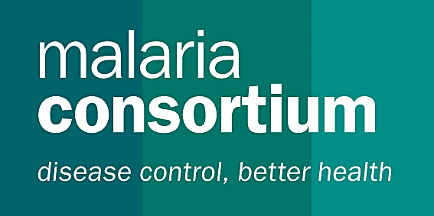

JOB DESCRIPTION

Job Title: Monitoring &Evaluation and Surveillance Specialist

Department: Technical

Reports To: GF Rd 10 Programme Manager

Technical support: Asia Technical Director and Global M&E Team

Direct Reports: M&E Technical Officers

Date Written/Last Reviewed: July 2012

Background: Malaria Consortium is an international non-government organization dedicated to improving delivery of prevention and treatment to combat malaria and other communicable diseases in Africa and Asia. It works with communities, health systems, government and non-government agencies, academic institutions, and local and international organizations, to ensure good evidence supports delivery of effective services, particularly providing technical support for monitoring and evaluation of programs and activities for evidence-based decision-making and strategic planning.

Malaria Consortium is a key partner of the national malaria programme in Thailand, working with the Department of Disease Control (DDC) and the Bureau of Vector Borne-Diseases (BVBD) in the monitoring and evaluation (M&E) of malaria activities in the country. Malaria Consortium is a sub-recipient (SR) of the Global Fund to fight AIDS, Tuberculosis and Malaria (GFATM) Single Stream Funding (Round 10) grant: “Containment of Artemisinin Resistance and Moving Towards the Elimination of Plasmodium falciparum in Thailand.” As an SR, Malaria Consortium works closely with DDC (the Principal Recipient, or PR) and BVBD to provide technical assistance and capacity development to the national programme and identified implementing partners of the GFATM R10 grant.

Job Purpose:
As part of a country team, the M&E and Surveillance specialist will provide technical assistance in refining and implementing the Thailand Global Fund M&E Performance Framework in alignment with the National Malaria M&E Plan, strengthening of malaria surveillance systems, harmonizing the use of information from various sources, and analyzing and reporting on M&E as required under the GFATM R10 grant. The M&E and Surveillance specialist will work closely with and provide technical guidance to DDC and BVBD to achieve the goals set by the grant partners.

Key Accountabilities:
As part of the Project team, the M&E and Surveillance Specialist will provide technical oversight for all monitoring and evaluation activitiesand support for strengthening of malaria surveillance systems, including the following tasks:
- Lead the Malaria Consortium M&E team for GFATM Rd10 and provide technical guidance to the PR and grant partners in M&E components of the grant, including large-scale malaria surveys;
- Provide technical inputs in the design, implementation, and refinement of a comprehensive M&E system to track and monitor progress based on the Performance Framework for the GFATM grant, in alignment with the National Malaria M&E Plan;
- Provide support to the PR and grant partners in the development and use of data collection tools in support of routine monthly reporting and M&E plans, including support for an online web-based M&E system;
- Oversee the design, implementation, and analysis, and report-writing of household and outlet surveys, including developing protocols, data collection tools and training materials for survey teams, as part of the M&E framework;
- Assist in the design and implementation of operational research activities to test new strategies and systems for surveillance, including the use of PCR and assessment of migrant and mobile populations’ classification and mapping
- Contribute to the strengthening of cross-border surveillance and data sharing as appropriate
- Support capacity-building at central and peripheral levels through training and systems support in M&E and surveillance;
- Support preparation of and participate in relevant technicalmeetings, workshops, and working groups;
- Provide monitoring and surveillance support to partners through regular field visits.
- Supervise the work of technical/M&E officer(s) based in Chiang Mai and/or Bangkok.
- Contribute as anactive member of the Malaria Consortium M&E cluster.
- Disseminate information through report writing, peer-review publications and presentations at national and international fora as appropriate.

PERSON SPECIFICATION

Qualifications:Advanced degreein public health (e.g. biostatistics, epidemiology) or a pertinent social science, such as demography

Essential:
- Strong analytical skills and extensive experience in M&E of projects and programmes.
- Demonstrated experience in survey design, implementation, analysis, and report-writing
- Experience with establishing, monitoring and assessing infectious disease surveillance systems
- Skilled in using STATA and other statistical packages such as EpiData, SAS, and SPSS.
- Proven experience in capacity-building/skills transfer
- Fluency in English
- Previous public health sector experience
- Experience working with government departments and/ or local/international NGOs

Desirable:
- Familiarity with IT systems and solutions
- Working knowledge of Thai
- Strong writing skills with publications in peer-reviewed journals
- Previous experience working in Thailand or one of the Mekong Sub-region countries.
- Understanding of the culture and working system / structure of the public health sector in Thailand

Work Based Skills and Competencies:
- Demonstrated ability to work independently as well as collaboratively on a team, particularly with Ministries of Health and/or other government sectors and partners
- Proven ability in transferring skills, particularly working with government and non-government colleagues
- Demonstrated verbal and written communication and presentation skills

ANY OTHER KEY INFORMATION

Contract duration: An initial period of 3 months (unaccompanied) with the strong possibility of full contract extension to 1 year when the Global Fund R10grant year 2 agreement is signed.

Travel: frequent travel expected within Thailand, with possible travel to neighbouring countries for cross-border information sharing.

Application information: Please send your CV and a letter detailing how you meet the selection criteria to HR.Recruitment@malariaconsortium.org by 27 August 2012.

